**Home Page**

**Logo of the school to the left side (Animated Gif to be left side of the page)**

**Pictures (5 Nos) Create – Liberate – Transform**

**Home Page** : Below the pictures :

**THIS IS MY CALL – THIS IS OUR CALL to immerse in human reality and to be a transforming presence in our context today.**

May we be guided by the light of compassion, the warmth of empathy, and the wisdom of experience. Let us approach each patient with reverence, recognizing the sacredness of their journey and the privilege of being invited into their lives during moments of vulnerability.

~~Compassionate Caregivers: We are the epitome of compassion, providing care that goes beyond medical treatments to comfort and support patients in their times of need.~~

**About Us**

The Rino Simoneti Memorial (R.S.M) School of Nursing was established in the year 2006 by Rt. Rev. Dr. George Mamlassery, the Bishop of Tura, Meghalaya, inaugurated by Mr. P A Sangma, Former Speaker of Lok Sabha and entrusted with the North East Society of the sisters of the Holy Cross, Menzingen, Switzerland.

The Holy Cross Sisters have been engaged in health care ministry and education globally for the past 200 years. The School of Nursing is attached to the Holy Cross Hospital, Tura, established in the year 1993.

The R.S.M School of Nursing aims to prepare professionally qualified nurses to meet the health care needs of the people, in the Christian spirit of service.

R.S.M School of Nursing is recognized by the Indian as well as the Meghalaya Nursing Councils for the revised General Nursing & Midwifery Course of three years.

At RSM School of Nursing, we believe in the transformative power of education and the profound impact nurses make in healthcare. More than an institution, our school is a community of passionate educators, dedicated students, and visionary leaders shaping the future of healthcare.

Established with a commitment to excellence, RSM has a rich heritage of producing exceptional nursing professionals. Our graduates are not just skilled practitioners but compassionate caregivers, innovative thinkers, and advocates of health equity.

Our cutting edge curriculum is designed to prepare students for the dynamic challenges of modern healthcare. Through a blend of theoretical knowledge and clinical practice, our students develop the critical thinking, clinical excellence, and ethical foundation needed to excel in their careers.

**Mission**

Rooted in the Gospel values of love, compassion, and justice, an institution of integrity strives to educate students to deliver holistic excellence in health care that addresses the physical, emotional, and spiritual needs of individuals and communities.

**Vision**

Instilling a culture of service and altruism in our students and moulding them to nurses who are not only skilled clinicians but also compassionate caregivers, ethical leaders, and faithful witnesses to the healing ministry of Jesus Christ.

**Core values**

* Compassion and caring
* Service to the needy
* Excellence in education
* Ethical practices
* Holistic approach to care
* Social justice and its advocacy
* Community collaboration
* Embracing the universality

**The motto of R.S.M School of Nursing is :**

**“THAT THEY MAY HAVE LIFE IN ITS FULLNESS” (JOHN 10:10).**

**Philosophy**

We the management and staff of R.S.M School of Nursing, believe that;

* God created all human beings in God’s own image and likeness. Therefore, we respect LIFE as sacred and precious from the moment of conception till its natural end.
* Health is the right of every individual and that we are called to promote health and prevent and cure illness wherever possible.
* Modern nursing education should keep abreast of the research and developments in the medical field.
* A substantial portion of learning in nursing is acquired through clinical practice.
* Nursing education should provide for the holistic development of students and also mould them to be providers of holistic health care to the needy.
* As responsible citizens of the country, the nurses can contribute significantly, towards building up of a healthy nation.

**Objectives**

On successful completion of the General Nursing Course of three years at RSM, a student being transformed to a meticulous and diligent nursing professional is expected to:

* Develop professional competence in planning and providing safe nursing care to patients suffering from any ailment, applying pertinent knowledge from both the biological and behavioural sciences.
* Acquire knowledge and competence to offer effective health education for preventing disease and promoting and restoring health.
* Uphold moral and ethical values in her personal and professional life.
* Collaborate constructively with the health team in institutional as well as community health care services.
* ~~E~~xhibit basic skills in managing hospital wards, as well as a community health units.
* Serve with tenderness, concern, respect and commitment to provide outstanding care.
* Build up the professional competence to be employed as staff nurses at health care centres or even multi speciality hospitals in the country as well as abroad.

**Our Founders**



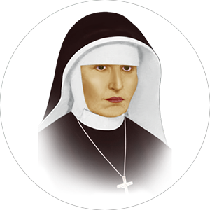

Fr. Theodosius Florentini Mother Bernarda Heimgartner

1822 - 1863

1808 - 1865

We are known as ‘Sisters of the Holy Cross Menzingen.’  As women of Hope we strive to be a ‘Transforming Presence’ and bear witness to Jesus Christ in the reality where we live and work.

As Sisters of the Holy Cross we owe a great debt of gratitude to our Founder Fr. Theodosius Florentini, a Franciscan Capuchin Friar (OFM) (1808-1865) and Mother Bernarda Heimgartner our Foundress (1822-1863). Our Congregation came to existence on 16 October 1844 at Menzingen in Switzerland. The Congregation, in its readiness to be of service to the society, took up health care, education, care of orphans and women in need and various other pastoral and social works extending far and wide.

Today as promoters of life we reach out to where life is endangered. We collaborate and network with health care organisations, governments and non-governmental agencies, social leaders, church Institutions, parishes etc. for the cause where justice, mercy and equality could be upheld.

**Message from Principal’s desk**

*The best way to find yourself is to lose yourself in the service of others*

*Mahatma Gandhi*

RSM School of Nursing is a distinguished institution rooted in the rich tradition of Catholic values. We are dedicated to foster excellence in nursing education, research, and clinical practice. Our commitment to provide supportive and innovative learning environment ensures that our students are equipped with the knowledge, skills, and values inevitable to surpass in the dynamic field of health care. We embrace the values of compassion, service, and excellence, inspired by the teachings of Jesus the great teacher. As the Principal of this institution, I am honoured to nurture both the minds and spirits of our students. Our rigorous academic programs empower our students to make a meaningful difference in the lives of those they care for. We believe that healthcare is not merely a profession but a sacred calling, and we are committed to instilling in our students a deep sense of responsibility even towards the most vulnerable members of our society.

Together, let us continue to uphold the values of compassion and excellence in nursing education and in our clinical field.

**Our Benefactors**

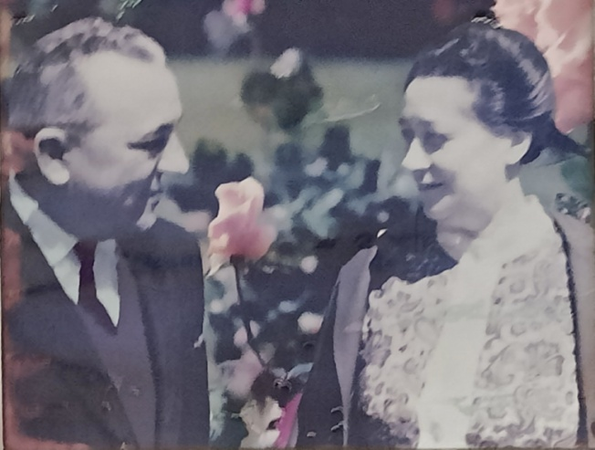

Mr & Mrs. Rino Simoneti, Italy

**Facilities**

**Hospital**

**Holy Cross Hospital, Walbakgre, Tura**

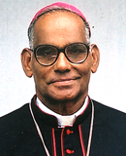

Rt. Rev. George Mamlassery, Bishop Emeritus, Tura

Holy Cross Hospital is a multi bedded, fabulously equipped hospital established in the year 1993 in Tura, West Garo Hills, Meghalaya, under the auspices of Holy Cross Congregation. It is the fulfilment of a great dream of Most Rev. George Mamlassery, the Bishop of Tura Meghalaya. The inadequate health care facilities existing in Garo Hills had invoked in his grace a missionary zeal to construct a 100-bed hospital. The hospital stands as a beacon of transformative impact, weaving hope and healing into the lives of hundreds of thousands of people from far and near.  With advanced facilities for minimally invasive and short-stay surgeries, the hospital, delivers accessible and profound services in a focused and caring environment. It offers affordable access to various medical and surgical specialties. Our diligent service focused on Christian values without compromising professional standards blending latest technology and ingenious procedures remains focused on outcomes to usher in healthy and happy days.

**Specialties**

Gynecology, Neonatology, Paediatrics, General medicine and Surgery, Laproscopic services

~~Ultrasound scanning, X-Ray, ECG and Echocardiography~~

**Medical assistance**

Cardiology, Urology, Paedriatric and general surgery, Orthopaedic and Laparoscopic surgeries

Amenities

 Ambulance

Anesthesiologist

Cardiologist

Cashless Insurance IconCashless Insurance

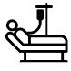ICU

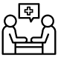OPD, Immunization

Operation Theatre, Modular OT

Neurologist

Pharmacy

**Diagnostic Services**

 X Ray, ECG

 Ultrasound scanning

 Clinical Pathology, Clinical Biochemistry, Haematology, Microbiology, Serology

**Library**

The school has a well established Library, where we foster an environment of learning and exploration for our students. Our library has computers and WIFI connections and it is a hub of academic support, and a gateway to the vast world of healthcare knowledge.

**Hostel Accommodation**

The course is strictly residential. All students will be provided hostel accommodation in the school campus.

As you step into our hostel, you will find a warm and inclusive environment where students from diverse backgrounds come together in pursuit of their nursing education. Our rooms are designed to provide comfort and privacy, ensuring that you have a peaceful haven to rest and recharge after a day of rigorous study and clinical practice. Here, lifelong friendships are forged, where students support and uplift each other through the challenges of academic life. Our common areas are vibrant hubs of activity, where you can unwind, socialize, and engage in meaningful conversations with your peers. Being the part of a Catholic institution, we offer opportunities for prayer, Holy Mass and spiritual guidance and counselling, providing a supportive environment for students to nurture their faith and deepen their connection to something greater than themselves.

**Admission**

**Course**

GNM Nursing

**Admission criteria**

1. Educational qualification: 10+2 with Minimum 40% marks in English and 50% in other subject from any recognized board. However Science is preferable.
2. Age: Minimum age for admission is 17yrs (as on 31st December of that year).
3. Ability to follow class room instruction in English.
4. Basic Computer course and Spoken English Certificate
5. Single females of good health, good moral character and aptitude for nursing.

**Selection and Admission**

* Duly filled application form, together with self-attested true copies of the documents mentioned therein, should reach the office on or before the stipulated date.
* Candidates eligible for admission will be called for a written test and a personal interview after initial screening of applications
* Selection list is finalised based on the pass in the entrance test and personal interview conducted by the management and clearance in the subsequent medical check up. The candidate shall bear the expenses towards any special investigation, if found necessary.

**Preliminary Course and Confirmation of Admission**

The provisionally selected candidates have to undergo a course of three months which will conclude with an examination. Candidates who exhibit the intellectual and practical ability and right aptitude for Nursing will have their admission confirmed. Those who fail in the examination will have to clear the examination or leave the Institution.

The students who gains admission for the course are expected to demonstrate diligence in their studies, both theoretical and practical, and to complete the course successfully in due time.

**Career**

**News and Events**

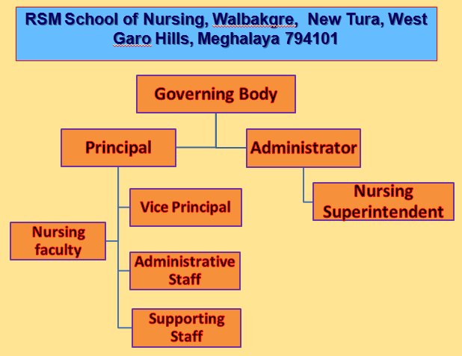

**Contact**

Principal, Rino Simonetti Memorial (RSM) School of Nursing, Holy Cross Hospital, Tura 794101

Phone :07005594107, 9378001174

Email: [rsmchooltura@gmail.com](mailto:rsmchooltura@gmail.com)